Tugas2 (HASHTABLE)

1. Method Find

Nama : Nico Ardia Effendy

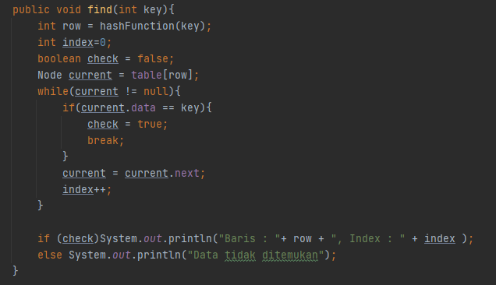

Kelas : J

Nim : 202010370311467